Short Bio for Seminar Intro Purposes:
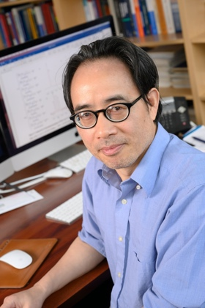
Eugene Chen received his undergraduate education and master degree in China. He earned his Ph.D. degree from The University of Massachusetts, Amherst, in 1995. After a postdoctoral stint at Northwestern University, he joined The Dow Chemical Company in late 1997, where he was promoted to Project Leader. He moved to Colorado State University as Assistant Professor in August 2000 and rose through the ranks to become Associate Professor in 2006 and Full Professor in 2009. He has been appointed as the Millennial Professor of Polymer Science and Sustainability since 2012, the John K. Stille Endowed Chair Professor in Chemistry since 2017, and a University Distinguished Professor since 2020. His current research is centered on polymer science, sustainable chemistry, and molecular catalysis. Selected honors and awards related to this lecture topics include: Excellence in Commercialization Award in 2012 by the Colorado Cleantech Industry Association; the Presidential Green Chemistry Challenge Award in 2015 by the US Government’s Environmental Protection Agency; and the Arthur Cope Mid-Career Scholar Award in 2019 by the American Chemical Society.

