Studying the chemistry of the radioelements at ultra-trace levels

With the development of nuclear medicine, the management of radioactive waste from the nuclear or non-nuclear industry, or, more fundamentally, in connection with the question of low doses effects on living organisms, the study of the behaviour of radioelements in aqueous medium is a key issue to consider. One of the important goals is to be able to describe the chemical forms present, to characterise the mechanisms leading to the formation of these species and finally to quantify the observations to supply the databases. This work is particularly delicate for the radiochemists, since it involves approaching the question at the ultra-trace scale either because the radioelement studied requires it (case of At, for example), or because the subject of study is characterised by such conditions (environment, medicine). In other words, the quantities handled are not weightable and do not allow, except under specific conditions, to access to spectroscopic tools to characterise the species formed. It is therefore necessary to develop indirect methodologies to obtain information at the molecular level, and the use of modelling tools (molecular or geochemical) is fundamental in this context. This presentation will be the opportunity to present examples acquired over the last 20 years, with a focus on the chemistry of astatine, the rarest element on earth, and the question of the availability/mobility of radioelements in the environment.

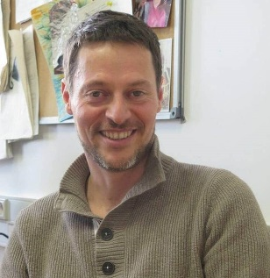
蒙达翁（Montavon）先生在法国亚原子物理技术研究所（SUBATECH）工作，在环境放射化学和医用放射性同位素化学性质方面有超过20年的研究积累。目前其研究重点是采用实验和模拟分析手段对放射性核素在超痕量浓度下的化学种态进行分析。他成功指导了数名科研工作人员、博士后和研究生开展环境放射化学和医用放射性同位素化学方面的研究工作。 他参与了多个欧盟项目，同时兼任多个法国国家研究机构（ANR）和国家放射性废物管理机构（ANDRA）项目的负责人。目前正在参与多项“学科前沿”项目，如labex IRON, Equipex ARRONAX+, CARAT等。他是法国高等教育研究和评估委员会高级专家，法国国家放射性废物管理局（ANDRA）和立陶宛能源研究所特聘专家；担任Inorg. Chem., Geochim. Cosmochim. Acta, Env. Sci. Technol, Radiochimica Acta等国际权威期刊审稿人。

