A Personal Journey into Mass Spectrometry and Beyond…

Determination of the relationship between changes in tissue and circulating forms and levels of proteins and their derivative peptides and the development of disease- or age-related physiological changes poses major challenges because of the broad dynamic range of the biologically active species, the structural complexity and diversity of co- and post-translational modifications, and the presence of numerous isomeric structures in biological samples. Prof.Costello’s group are developing and applying mass spectrometry-centered methods that are compatible with on-line separations (pre- and post-ionization) and electron-based dissociation modes that preserve labile protein modifications while producing highly informative fragmentation. Illustrations will include examples from earlier work that drove the development of current approaches. Recent and ongoing studies utilize a variety of MS techniques that enable comprehensive proteomic and glycoproteomics analyses of clinical samples and model cell systems that are relevant to development of vaccines, cancer therapeutics, diagnostics, and tools for combating infectious diseases, and to increased understanding of the pathways underlying protein misfolding disorders.

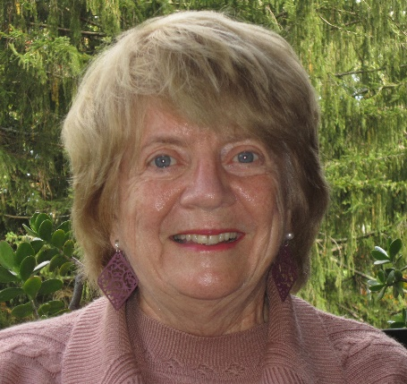
Catherine E. Costello is a William Fairfield Warren Distinguished Professor at Boston University (BU), with appointments in the Depts. of Biochemistry, Physiology & Biophysics, and Chemistry. She earned her AB at Emmanuel College, Boston, and her MS and PhD at Georgetown University, Washington, DC. She was the Associate Director of the NIH Mass Spectrometry Resource at MIT for more than 20 years, then turned her attention fully toward addressing questions related to human health by founding the BU School of Medicine Center for Biomedical Mass Spectrometry in 1994. Her research centers on development of mass spectrometry-based instrumentation and methods for biopolymers and their application to study glycobiology, protein post-translational modifications, protein misfolding disorders, cardiovascular and infectious diseases, and bioactive lipids. She has authored about 400 scientific papers. She is Immediate Past President of the International Mass Spectrometry Foundation; she was President of the American Society for Mass Spectrometry in 2002-2004 and the International Human Proteome Organization in 2011-2012. She has received several major awards in the fields of mass spectrometry, proteomics and chemistry and is a Fellow of the American Chemical Society and the American Association for the Advancement of Science.

