Making Enzymes from Scratch

Biocatalysis is emerging as a key enabling technology for the development of a greener and more efficient chemical industry. Because natural enzymes are seldom suitable for direct use in chemical processes, however, protein engineering is typically required to optimize their properties for practical applications. For many desirable chemical transformations, natural enzymes may not even exist. Recent advances on the computational design of atomically accurate protein structures, combined with high-throughput evolutionary optimization, are providing a potential roadmap for reliably creating new-to-nature biocatalysts in response to diverse societal demands. In this lecture, the strategies, opportunities, and challenges facing this emerging field will be surveyed.

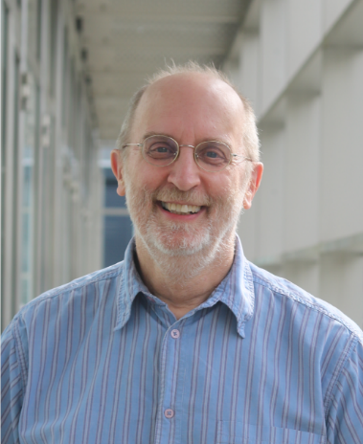
Donald Hilvert has been full Professor at the Organic Chemistry Laboratory of ETH Zürich since October 1, 1997. His group is developing general strategies for the design of proteins with customized catalytic properties. The aim is to gain a better understanding of the molecular origins of the catalytic powers of natural enzymes and their selectivity. Beyond that artificial biocatalysts may be useful in research, medicine and industry.
Professor Hilvert was born in 1956 in Cincinnati, Ohio, USA, and obtained his B.A. from Brown University, Rhode Island, in 1978. He earned his Ph.D. from Columbia University, New York, in 1983, with a dissertation under the supervision of Prof. R. Breslow. Following a postdoctoral work with Prof. E.T. Kaiser at Rockefeller University, New York, he joined the Scripps Research Institute as an assistant professor in 1986, where he was named associate professor in 1989 and full professor in 1993. He came to ETH Zürich as full Professor of Organic Chemistry in 1997.
Professor Hilvert was awarded the Alfred P. Sloan Research Fellow in 1991-93; Arthur C. Cope Scholar Award, American Chemical Society in 1992; Pfizer Award in Enzyme Chemistry in 1994; The Emil Thomas Kaiser Award, The Protein Society in 2009; Goldene Eule & Credit Suisse Award for Best Teaching in 2011; Feodor Lynen Medal, German Society for Biochemistry and Molecular Biology in 2016; Biocat Award in 2016; Moore Distinguished Scholar, Caltech in 2019, 2020; Ronald Breslow Award for Achievement in Biomimetic Chemistry, American Chemical Society in 2020. Professor Hilvert is the fellow of the American Association for the Advancement of Science, the Royal Society of Chemistry, American Academy of Arts and Sciences. He is Honorary Professor of Tianjin University.

