The High throughput Chemical Characterization of Cells
using Mass Spectrometry

While the need for single cell chemical measurements of heterogeneous brain cells has been well established, the large number of cell types suggests that thousands to tens of thousands of measurements are required to characterize representative cell types in a brain region. Approaches for assaying the chemical content within populations of individual brain cells are highlighted, including mass spectrometry imaging (MSI) and single cell mass spectrometry measurements. Using these approaches, we can measure lipids, fatty acids, neurotransmitters and neuropeptides, among others. For the high throughput measurements, the cells of interest are scattered across a microscope slide, the exact cell positions determined via optical microscopy, and mass spectra are acquired only at the cell positions. Because the spaces between the cells are not measured, the approach is efficient and rapid. Using new mass analyzers, high acquisition rates and high information content is possible. The single cell assays allow differences in the metabolome and peptidome from supposedly homogeneous populations of cells to be explored. By obtaining information from tens of thousands of individual cells, rare cells are found and unusual neurochemicals are discovered. For select cells, follow-up capillary electrophoresis-mass spectrometry is performed. We have recently adapted the approach to work with individual cellular organelles such as dense core vesicles and mitochondria providing us with more detail on organelle heterogeneity. This has allowed us to characterize distinct populations of vesicles that contain varying peptide hormones. Our overarching goal is to uncover the complex chemical mosaic of the brain and pinpoint key cellular players involved in a range of physiological and pathological processes.

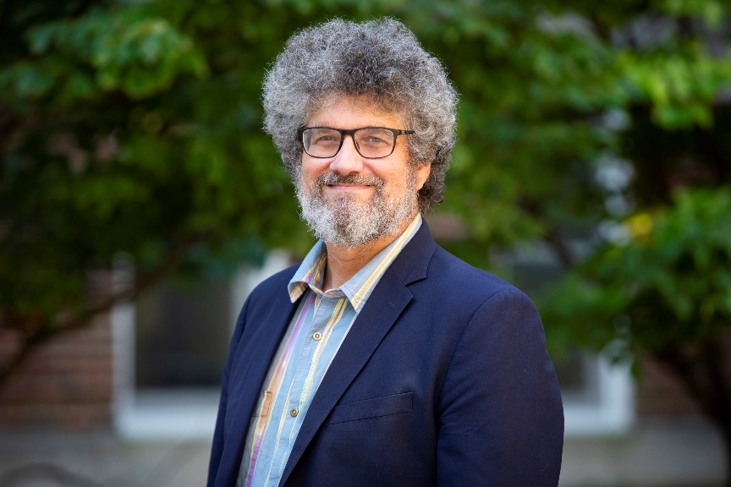

Jonathan V. Sweedler is the James R. Eiszner Family Endowed Professor of Chemistry and Director of the School of Chemical Sciences at the University of Illinois at Urbana-Champaign. His overarching research emphasizes bioanalytical chemistry/measurement science technology development, and the study of cell-cell signaling. He is recognized for creating innovative approaches for small-volume mass spectrometry (MS) and used these approaches to probe single cells for their proteins, peptides and metabolites. Recent advances allow them to probe tens of thousands of cells for their chemical content and select specific cells for follow-up MS-based measurements. Together with their collaborators, they have interrogated the genome, transcriptome, and peptidome in a broad range of animals, uncovered signaling molecules and pathways involved in diverse functions and behaviors, and characterized neuropeptides in the honey bee, planarian, songbird, sea snail, and multiple mammalian species, as well as in individual cells and vesicles.
The impact of Jonathan’s work is reflected in 500+ research and review articles, patents, and book chapters. His achievements have been recognized by numerous awards, including the CASSS Award for Outstanding Achievements in Separation Science, Torbern Bergman Medal, Visionary Award from the American Diabetes Association, ANACHEM Award, Malcom E. Pruitt Award, and ACS Analytical Chemistry Award; and he has been recognized several times by The Analytical Scientist on their Power List of Analytical Chemists, including twice at the number one spot. He is a Fellow of the American Association for the Advancement of Science, American Chemical Society, the Royal Society of Chemistry, and serves as Editor-in-Chief of Analytical Chemistry.

