From the Norbornyl Cation Story to Basic Organometallic & Inorganic Coordination Chemistry at Iron and Uranium
– Touring the Periodic Table from Top to Bottom

The chemistry in the Meyer laboratory focuses on the synthesis of custom-tailored ligand environments and their d and f-block metal coordination complexes. These complexes often exhibit unprecedented coordination modes and unusual electronic structures; and consequently, enhanced reactivities towards small molecules of biological and industrial importance, which we aim to (photo-electro-chemically) activate and functionalize. Synthetic chemistry is at the heart of their research program and modern crystallographic, spectroscopic, and computational methods are applied to elucidate the molecular and electronic structures and the origin of reactivity of our newly synthesized molecules.
In this seminar, Prof. Dr. Karsten Meyer briefly highlight their collaborative efforts to elucidate the unusual structures of the archetypal non-classical norbornyl cation ^{[1]} and organometallic Fe(IV) derivatives of the classic ferrocene^{[2]}. Advancing the coordination chemistry of tripodal N-heterocyclic carbene ligands allowed for the synthesis and structural characterization of Fe(IV) ^{[3]} and Fe(V) ^{[4]} nitrido complexes. Their study on high-valent iron nitrides {Fe–N} eventually led to the currently most complete series of iron nitrosyl complexes, the pentade {Fe–NO} ^{[6-10]} . Surprisingly, high-valent {Fe–N} and low-valent {Fe–NO} are structurally and electronically very closely related to each other. Finally, we present our efforts on the uranium-based activation and functionalization of CO₂ ^{[5]} , which, ultimately, led to the development of f-element uranium ^{[6]} and lanthanide-based ^{[7]} molecular catalysts for the electrocatalytic production of H₂ from H₂O.

^{[1]} F. Scholz, D. Himmel, F.W. Heinemann, P.v.R. Schleyer, K. Meyer and I. Krossing in Science 2013, 341,62.
^{[2]} M. Malischewski, M. Adelhardt, J. Sutter, K. Meyer and K. Seppelt in Science 2016, 353, 678.
^{[3]} C. Vogel, F. W. Heinemann, J. Sutter, C. Anthon and K. Meyer in Angew. Chem. Int. Ed. 2008, 47, 2681.
^{[4]} J.J. Scepaniak, C.S. Vogel, M.M. Khusniyarov, F.W. Heinemann, K. Meyer and J.M. Smith in Science 2011,331, 1049.
^{[5]} a) I. Castro-Rodriguez, H. Nakai, L. Zakharov, A.L. Rheingold and K. Meyer in Science 2004, 305, 1757.b) I. Castro-Rodriguez and K. Meyer in J. Am. Chem. Soc. 2005, 127, 11242. c) S.C. Bart, F.W. Heinemann, E. Bill, N.M. Edelstein and K. Meyer in J. Am. Chem. Soc. 2008, 130, 12536. d) S.J. Zuend, O.P. Lam, F.W.Heinemann and K. Meyer in Angew. Chem., Int. Ed. 2011, 50, 10626. e) A.-C. Schmidt, A. Scheurer, F.W.Heinemann and K. Meyer in Chem. Commun. 2012, 48, 8634. f) A.-C. Schmidt, F.W. Heinemann, L. Maron, P.W. Roesky and K. Meyer in Chem. Eur. J. 2014, 20, 13501.
^{[6]} a) D.P. Halter, F.W. Heinemann, J. Bachmann and K. Meyer in Nature 2016, 530, 317. b) D. P. Halter, F.W. Heinemann, L. Maron and K. Meyer in Nature Chem. 2018, 10, 259.
^{[7]} D.P. Halter, C. T. Palumbo, J. W. Ziller, M. Gambicki, A. L. Rheingold, W. J. Evans and K. Meyer in J. Am.Chem. Soc. 2018, 140, 2587.

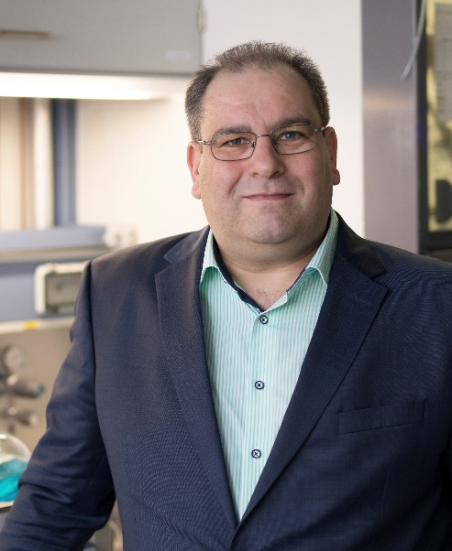

Karsten Meyer studied chemistry (October 1989 – 1994) at the Ruhr-University of Bochum (Germany) and received his Diploma in May 1995. Starting in summer 1995, he performed his PhD thesis work under the direction of Professor Karl Wieghardt at the Max-Planck-Institute in Mülheim / Ruhr (Germany) and received his Ph.D. (Dr. rer. nat, summa cum laude) in January 1998. With a DFG post¬doctoral fellow¬ship, Karsten proceeded to gain research experience in the laboratory of Professor Christopher Cummins at the Massachusetts Institute of Technology (1998 – 2000, MIT, Cambridge, MA, USA). In January 2001, he was appointed to the faculty of the University of California, San Diego (UCSD) as an Assistant Professor and was named an Alfred P. Sloan Fellow in 2004. In 2006 he accepted an offer (C4/W3) to be the Chair of the Institute of Inorganic & General Chemistry at the Friedrich-Alexander-University of Erlangen-Nürnberg (FAU), Germany.
Karsten Meyer has published 250+ publications in peer-reviewed journals, leading to an h-Index of 60 with a total of 10,000+ citations, and an average citation per item of 40. The list of publications includes, among others, reports and articles in Science, Nature, Nature Chem., Chem, Journal of the American Chemical Society, Angewandte Chemie, and Chemical Science. He has given more than 200 invited talks, including opening and plenary lectures, at conferences as well as research and academic institutions worldwide. He received Alfred P. Sloan Award, USA(2004), Israel Chemical Society, Lifetime Honorary Member, IL(2009), Japanese Society for the Promotion of Science Award (JSPS), JP(2009), Elhuyar-Goldschmidt Award, Royal Society of Chemistry of Spain(2017), Ludwig-Mond Award, Royal Society of Chemistry (UK)(2017) and Chugaev Commemorative Medal, Kurnakov Institute, Moscow, Russian Academy of Sciences(2017).

