【无机化学论坛】 Development of Advanced Porous Organic Polymers as a New Platform for Biomimetic Catalysis

报告人: Prof. Shengqian Ma (马胜前)
Department of Chemistry, University of South Florida

时间：2019年5月15日（周三） 上午10:30—11:30
地点：北京大学化学学院A区717报告厅.
Abstract:
Porous organic polymers (POPs) both amorphous and crystalline represent an emerging class of nanoporous materials, and they feature robust covalent framework structures with high water and chemical stability. This, together with their high surface areas and tunable pore sizes, makes them hold promise for a variety of applications. We will demonstrate how POPs can be developed as a new platform for biomimetic catalysis.
Biographical Sketch:
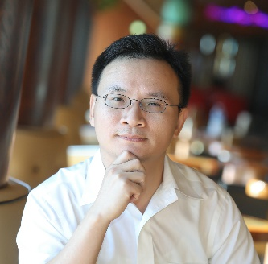
Shengqian Ma obtained his B.S. degree from Jilin University, China in 2003, and graduated from Miami University (Ohio) with a Ph.D. degree in 2008. After finishing two-year Director’s Postdoctoral Fellowship at Argonne National Laboratory, he joined the Department of Chemistry at University of South Florida (USF) as an Assistant Professor in August 2010. He was promoted to an Associate Professor with early tenure in 2015 and to a Full Professor in 2018.
He received the USF Faculty Outstanding Research Achievement Award in 2015 and the USF Outstanding Faculty Award in 2018. He is the recipient of 2014 NSF CAREER Award and has been selected as the Thomson Reuters Highly Cited Researcher in 2014, 2015, 2016, 2017, and 2018; he was also awarded the IUPAC-2015 Young Chemist Travel Award and the 2009 IUPAC Prize for Young Chemists from International Union of Pure & Applied Chemistry (IUPAC); he received the Young Investigator Award from American Chemical Society (ACS) Division of Inorganic Chemistry and the Director’s Postdoctoral Fellowship from Argonne National Laboratory in 2008 as well.
His current research interest focuses on the development of functional porous materials including metal-organic frameworks (MOFs), covalent organic frameworks (COFs), porous organic polymers (POPs), and microporous carbon materials for energy, biological, environmental-related applications. He has published more than 180 papers (over 140 since independent career) with the total citations over 17600 and the H-index of 66.

