北京大学——台湾大学化学学术研究交流会
时间：2019年5月8日（周三）8:50-17:30
地点：A204（学生报告）/A205（教师报告）
负责人：甘良兵
欢迎参加！
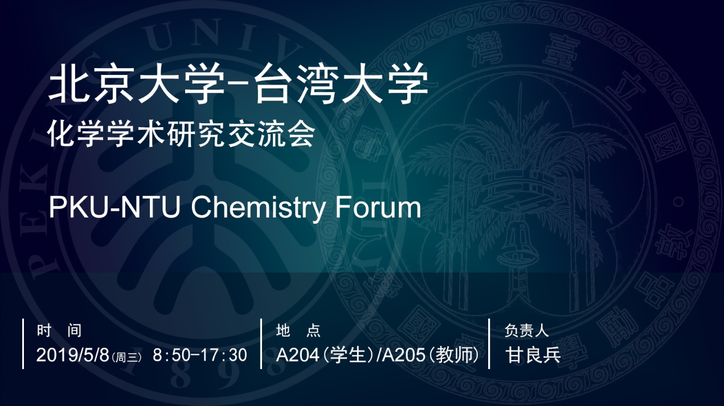

双边研究生学术交流会（A204）
时间 | 报告人 | 报告主题
8:50-9:05 | 黃志盛  （臺灣大學） | Molybdenum Disulfide Nanomaterials for Lithium-CO₂ Battery Cathode Catalysts
9:05-9:20 | 谢肖  （北京大学） | Genetically Encoded Multifunctional Protein Photocrosslinkers
9:20-9:35 | 張修菩  （臺灣大學） | Stereodynamic Study of Spatially Oriented 1-bromo-2-methylbutane Through Ion Imaging Technique
9:35-9:50 | 李思伟  （北京大学） | Impact of Coordination Environment on Atomically Dispersed Pt for Oxygen Reduction Reaction
9:50-10:05 | 郭廷浩  （臺灣大學） | A Universal Mass Spectrometric Method for identification and quantification of Lipid Double-bond Positional Isomers Enabled by mCPBA Epoxidation
10:05-10:20 | 饶海霞  （北京大学） | Inorganic Functional Materials in p-i-n Heterojunction Perovskite Solar Cells
10:20-10:45 | 茶歇
10:45-11:00 | 邱子瑋  （臺灣大學） | Synthesis, Characterization, and Immunogenicity of O-specific Polysaccharide-based Glycan Vaccine against Salmonella Typhimurium
11:00-11:15 | 刘志亮  （北京大学） | The Synthesis Method and Lithium/Sodium Storage Performance Studies of Silicon and Metal Phosphide Nanomaterials
11:15-11:30 | 成凱翔  （臺灣大學） | Large-Area Synthesis of Ambipolar Single Crystalline Rhenium Diselenide for Near-Infrared Light-Emitting Diodes
11:30-11:45 | 宁莹莹  （北京大学） | Design of Highly Luminescent Ytterbium(III) Molecular Probes for NIR Bioimaging
11:45-14:00 | 午餐
14:00-14:15 | 陳子建  （臺灣大學） | Probing the Helical Inversion of a Molecular Switch with a Molecular Rotor
14:15-14:30 | 杜山山  （北京大学） | Dilithio Reagents and Metallacyclopentadienes Mediated P4 Activation
14:30-14:45 | 張峻瑋  （臺灣大學） | Indicator-assisted Control and Guidelines for Glycosylation Reactions via Reactivity and Intermediate
14:45-15:00 | 覃珂  （北京大学） | Quantitative Profiling of Protein O-GlcNAcylation Sites And Discovery of Artificial S-Glycosylation by an Isotope-Tagged Cleavable Linker
15:00-15:15 | 張晏展  （臺灣大學） | Direct Observation of the Protein-DNA Interaction Using Passive Force-Clamp Optical Tweezers
15:15-15:30 | 邓兵  （北京大学） | Graphene as Electronic Materials: Growth of Single-Crystal Graphene Wafer
15:30-15:50 | 茶歇
15:50-16:05 | 簡翊庭  （臺灣大學） | Effect of Mesoporous Silica Nanoparticle Properties and Associated Protein Corona on Nano-Bio Interactions
16:05-16:20 | 董博为  （北京大学） | Quantum Coherence in Molecular Magnets
16:20-16:35 | 鄭郁璇  （臺灣大學） | Charge-Transfer Induced Anion Migration Probed by the Linear D-π-A Phosphonium Fluorophores
16:35-16:50 | 王立刚  （北京大学） | Stable and Efficient Lead Halide Perovskite Optoelectronic Devices
16:50-17:30 | 自由讨论

双边教师学术交流会（A205）
时间 | 报告人 | 报告题目
8:50-9:20 | 彭旭明  （臺灣大學） | Molecular Metal Wires: From Homonuclear Metal String Complexes to Heteronuclear Metal String Complexes
9:20-9:50 | 吴凯  （北京大学） | Mediating Surface Reactions with Molecular Assembly Strategy
9:50-10:20 | 李弘文  （臺灣大學） | Single-molecule Mechanistic Studies of How Accessory Protein Stimulates Recombinase Filament Assembly
10:20-10:40 | 茶歇
10:45-11:15 | 刘志伟  （北京大学） | Electroluminescence Study of Rare Earth Complexes
11:15-11:45 | 江建文  （臺灣大學） | Organometallics-Based SERS Reporters
11:45-14:00 | 午餐
14:00-14:30 | 李彦  （北京大学） | In situ study of Tungsten-Cobalt Intermetallic Nanocrystals in Reactive Environment at High Temperature
14:30-15:00 | 牟中原  （臺灣大學） | Mimicking the Structure and Function of Diatom Frustle
15:00-15:30 | 蒋尚达  （北京大学） | Adiabatic Control of the Quantum Phase by Electric Field in a Rare Earth Crystal
15:30-15:50 | 茶歇
15:50-16:20 | 張慕傑  （臺灣大學） | Reversible Homolytic Activation of Water via Metal-Ligand Cooperativity in a T-Shaped Ni(II) Complex
16:20-16:50 | 黄闻亮  （北京大学） | Inverse sandwich Arene Complexes of f-Elements: Synthesis, Characterization and Electronic Structure
16:50-17:30 | 自由讨论

