Hunting for the Hidden Chemistry in Solid Catalysts: Towards a Molecular Movie

Bert M. Weckhuysen, Inorganic Chemistry and Catalysis group, Debye Institute for Nanomaterials Science, Utrecht University, Universiteitsweg 99, 3584 CG Utrecht, The Netherlands; b.m.weckhuysen@uu.nl

The search for new or more effective solid catalysts would benefit when we could bridge the molecular world with the macroscopic world. Such detailed information can be realized if we would have access to a very powerful camera shooting molecular movies of an active catalytic solid at a submolecular level. This is the field of operando spectroscopy and recent breakthroughs in chemical imaging techniques, based on optical, electron and X-ray methods, demonstrate that such molecular movie concept is within reach.

This lecture discusses the recent advances in spectroscopy and microscopy of catalytic solids at different length scales, starting from single molecules and single atoms up to the level of individual catalyst particles. Special emphasis will be devoted to the exploration of mesoscale effects in catalytic solids as well as on the scientific challenges ahead to make such molecular movie reality.

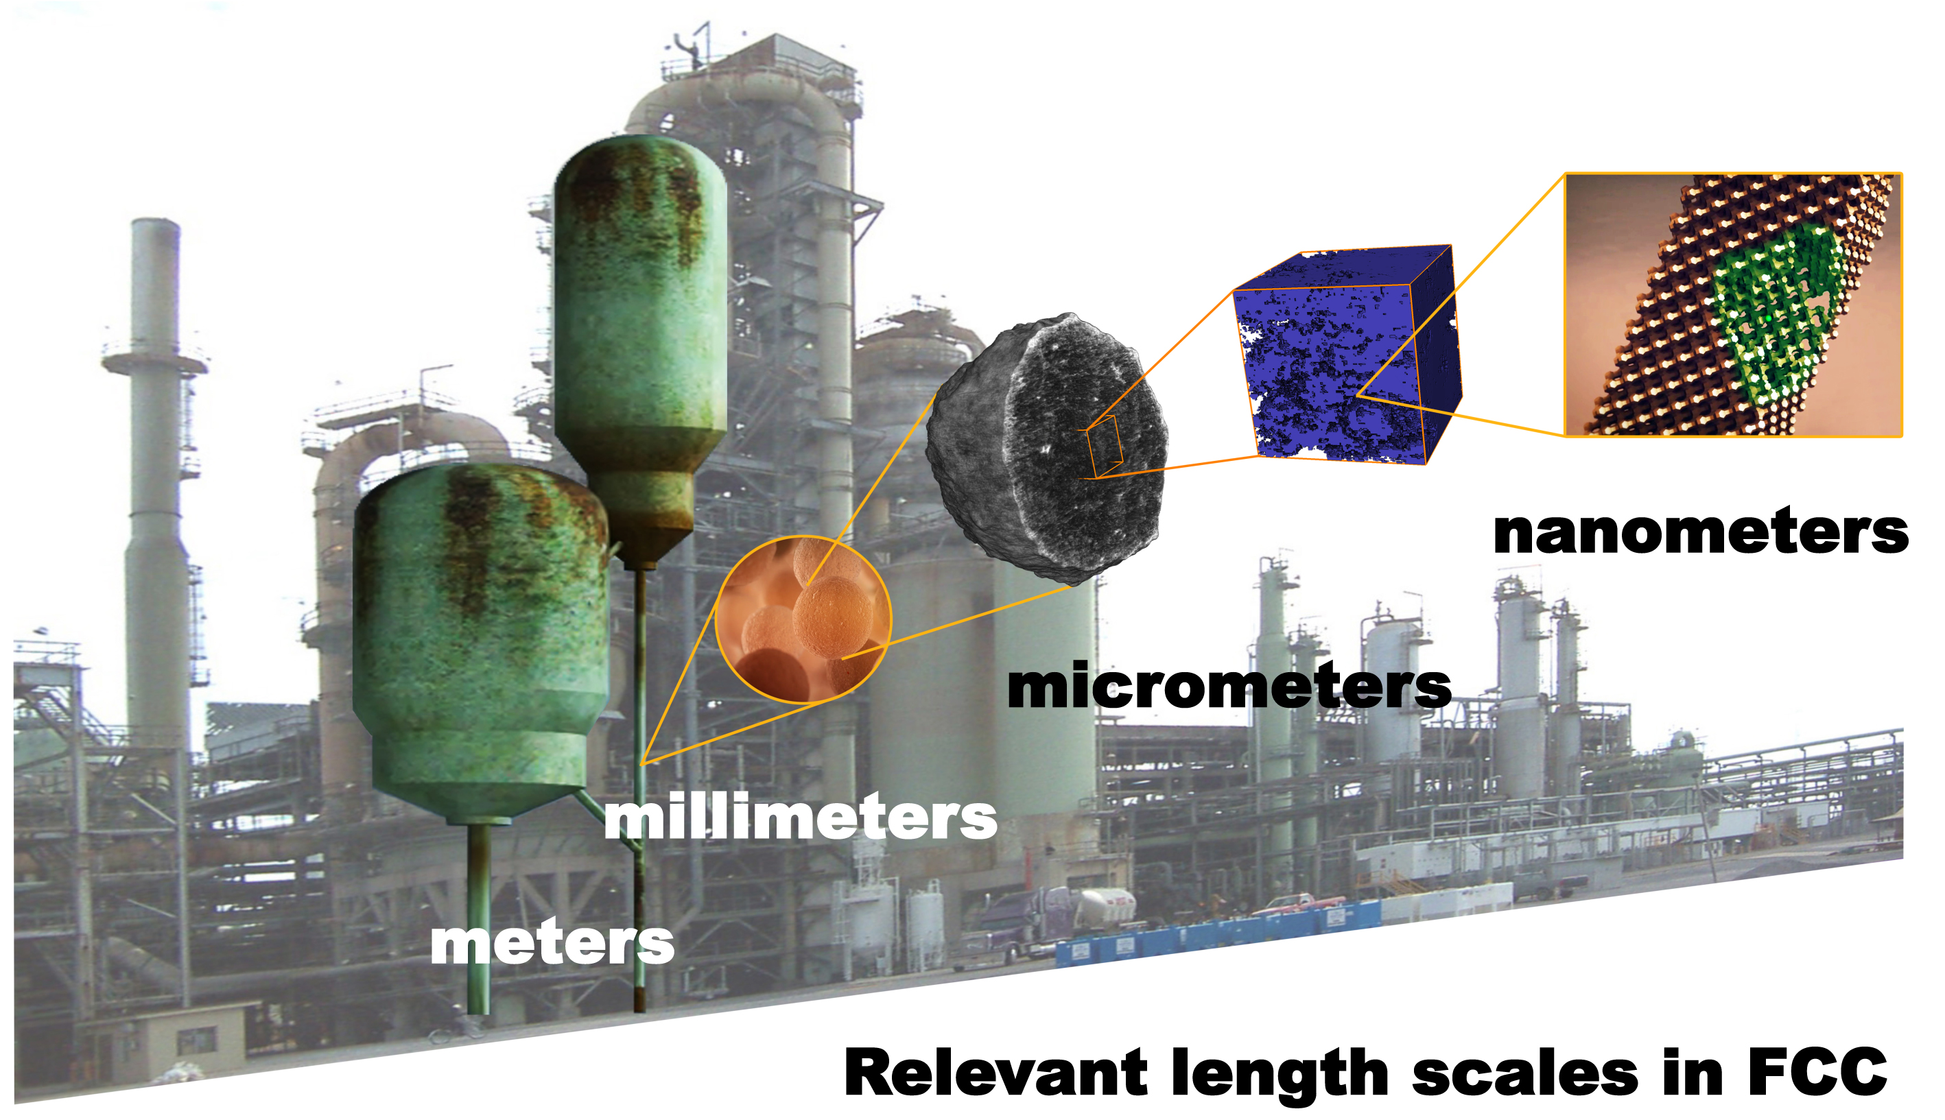
Figure. Heterogeneous catalysis as a multiscale science and technology, in which the macroscopic world of catalytic activity, selectivity and stability as measured in a catalytic reactor connects via the mesoworld with the nanoworld of individual atoms and molecules. Operando spectroscopy of a catalytic solid should enable us to create a “Google earth” camera viewing the working catalyst, including both the organic and inorganic part of chemical processes, at different length scales.

