SAXS characterization of core-shell nanoparticles

Oleksandr O. Mykhaylyk

Soft Matter AnalyticaL Laboratory (SMALL)
Department of Chemistry, University of Sheffield, Sheffield, S3 7HF, UK

Abstract
Small-angle X-ray scattering is a non-destructive methods conveniently designed for structural characterization of soft matter materials from nano- to micron scales. Recent developments of X-ray optic components, synchrotron radiation sources and laboratory SAXS instruments, complimented by a further progress in modelling and analysis, made SAXS technique one of the most reliable (and popular) for structural characterization of nanoparticles and colloids. In this respect, spherical core-shell particles represent a very wide group of structural organizations taking place in nature: homogeneous spheres, vesicles, multilamellar vesicles, liposome, polymersomes, micelles, core-shell particles with a single shell and onion-like core-multi-shell formations. Density fluctuations and phase-separation taking place in the core and/or the shell may complicate the structure causing both formation of substructure or irregularities within the particle components. An application of reciprocal space models and real space models together with contrast variation techniques for structural characterization of core-shell particle formations will be demonstrated in the talk. In particular, a step-by-step process of SAXS model development for structural characterisation of both block copolymer spherical micelles (using reciprocal space) and core-shell polymer nanoparticles (using real space) will be presented.

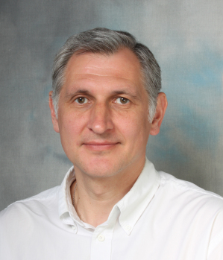
Dr. Sasha Mykhaylyk obtained his MSc in Physics (optics and spectroscopy) from Taras Shevchenko Kiev State University in 1991 (Diploma with distinction was awarded on graduation). After obtaining a PhD in solid state physics and crystallography from the Institute for Problems of Materials Science (the Ukrainian Academy of Sciences) in 1996, he became a Research Scientist at the same institute where he was later promoted to a Senior Scientist. After holding Royal Society/NATO Fellowship at the University of Cambridge in 2000-2001 he joined the University of Leeds in 2002 as a Research Associate. He moved to the University of Sheffield in 2004 where he was promoted to a Research Fellow in 2011 and Senior Research Fellow in 2017.

